The Title Goes Here With Each Initial Letter Capitalized(16 pt. bold, centered)
First Author¹, Second Author², and Third Author³(12pt, bold, centered)
¹Materials Physics Division, ²Materials Chemistry Division, Institution Address, City, Code
³Crystal Growth Center, City, Code (10 pt, centered)
*Corresponding author: your@emailaddress.in

Abstract
Do not replace the word “abstract,” but do replace the rest of this text. Each paper must include an abstract. Begin the abstract with the word “Abstract” followed by a period in bold font, and then continue with a normal 9 point font You may want to print this page and refer to it as a style sample before you begin working on your paper. Page limit for contributory paper is 2page. For YAA/Thesis page limit: 3page. Paper size: Letter with margin: left = right = 2.54cm, top =bottom =3.0 cm.

Introduction
The first Heading of your manuscript must use the style “Introduction” Otherwise, your paragraph spacing will be off. This is the standard font and layout for the individual paragraphs. The style is called "Paragraph." Replace this text with your text. The "Enter" key will take you to a new paragraph. If you need to insert a hard line break within the paragraph, please use Shift + Enter, rather than just tapping the "Enter" key.
This is the paragraph spacing that occurs when you use the Enter key. This is the standard font and layout for the individual paragraphs. The style is called "Paragraph." Replace this text with your text. The "Enter" key will take you to a new paragraph. If you need to insert a hard line break within the paragraph, please use Shift + Enter, rather than just tapping the "Enter" key.
This is the paragraph spacing that occurs when you use the Enter key. This is the standard font and layout for the individual paragraphs. The style is called "Paragraph." Replace this text with your text. The "Enter" key will take you to a new paragraph. If you need to insert a hard line break within the paragraph, please use Shift + Enter, rather than just tapping the "Enter" key. This is the paragraph spacing that occurs when you use the Enter key. This is the standard font and layout for the individual paragraphs. This is the paragraph spacing that occurs when you use the Enter key.This is the standard font and layout for the individual paragraphs. The style is called "Paragraph." Replace this text with your text. The "Enter" key will take you to a new paragraph. If you need to insert a hard a new paragraph. If you need to insert a hard line break within the paragraph, please use If yoi need to insert a hard line break within the paragraph, please use “double column” format for writing the DAE-SSPS 2021 manuscript.

Headings
Section heading should be in Times New Roman 10 pt, bold, all capitals. A spacing of 4 mm separates the section headings from the preceding and the following paragraphs. The first paragraph after the title in each section is not indented. The first line of all the subsequent paragraphs is indented by 5 mm. paragraphs is indented by 5 mm
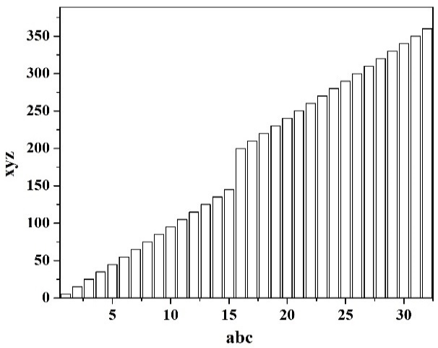
Fig. 1. This is the Style for Figure Captions. Center this if it doesn’t run for more than one line.
To insert a footnote, use the "Insert" menu, select "Footnote", and click "OK"Below is an example equation created with Word Equation EditorBelow is an example equation created with Word Equation Editor. To move this equation, highlight the entire line, then use cut and paste to the new location.
The current COVID pandemic situation has led to the cancellation of several scientific symposia in the last year, including the 2020 DAE-SSPS conference that was to be held at BARC, Mumbai during December 2020.
This has adversely affected the researchers in the community more specifically the younger researchers, who have missed a golden opportunity to present both, their work and themselves, to the rest of the scientific community. For more senior researchers, this has impacted their interactions in the community, affecting new ideas and new collaborations.
Since the pandemic is still ongoing and far from over, the current 65th DAE-SSPS-2021 is planned to be held in hybrid mode. In this mode, local participants from Mumbai will be participating physically, whereas all others will participate virtually via on-line platform.
This hybrid mode is expected to be more convenient and safer for participating, considering the current pandemic situation, while reaping the benefits of the conference. This hybrid mode is expected to be more convenient and safer for participating, considering the current pandemic situation, while reaping the benefits of the conference.
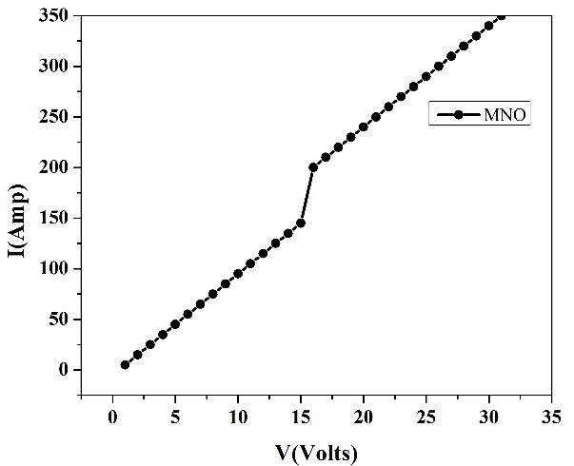
Fig. 2. This is the Style for Figure Captions. Center this if it doesn’t run for more than one line.
Since the pandemic is still ongoing and far from over, the current 65th DAE-SSPS-2021 is planned to be held in hybrid mode. In this mode, local participants from Mumbai will be participating physically, whereas all others will participate virtually via on-line platform. Once the manuscript is written as per the format in MS Word DOCX. it should be compiled and converted to a pdf file. You will need to create a ‘user account’ at the symposium website to submit a paper. Please download ‘double column’ template file (*.docx) from the symposium website to prepare manuscripts. The DOCX files of manuscript as well as a PDF version of the manuscript have to be uploaded at the website. a paper. Please download ‘double column’ template file (*.docx) from the symposium website to prepare manuscripts. The DOCX files of manuscript as well

Table 1. Type Table Name Here.
Column Header Goes Here | Column Header Goes Here
Row Name Goes Here | x
Row Name Goes Here | x
Row Name Goes Here | x

General Guidelines
Once the manuscript is written as per the format in MS Word DOCX. it should be compiled and converted to a pdf file. You will need to create a ‘user account’ at the symposium website to submit a paper. Please download ‘double column’ template file (*.docx) from the symposium website to prepare manuscripts. The DOCX files of manuscript as well as a PDF version of the manuscript have to be uploaded at the website.
It is not encouraged to have the figures and tables together to occupy more than 50% of available area. Also the content should be sufficient and complete. Authors are also expected not to split their work to submit multiple contributions. Although the contributions are in soft copy form, the symposium organizer will not make any attempt to edit it to conform to the template format.
After screening of the contributions, the acceptance status of the papers shall be made available only on the website.
Acknowledgement
The reference section will follow the “Acknowledgment” section. References should be numbered using Arabic numerals followed by a period (.) as shown below, and should follow the format in the below examples.
References
- M. P. Brown and K. Austin, The New Physique, Publisher City: Publisher Name, 2005, pp. 25-30.
- M. P. Brown and K. Austin, Appl. Phys. Letters85, 2503-2504 (2004).
- R. T. Wang, “Title of Chapter,” in Classic Physiques, edited by R. B. Hamil, Publisher City: Publisher Name, 1999, pp. 212-213.
- T . H. Wien,“Title of Chapter,” in Classic Physiques, edited by R. B. Hamil, Publisher City: Publisher Name, 1999, pp. 212-21.
- T. H. Hardy, Appl. Phys. Letters85, 2503-2504 (2004).

